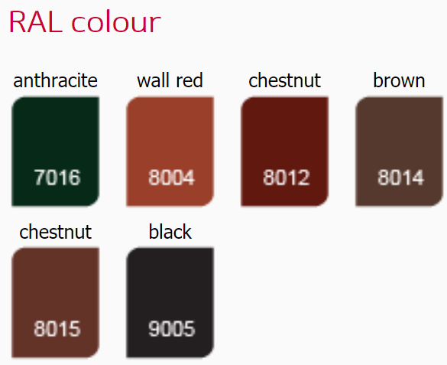
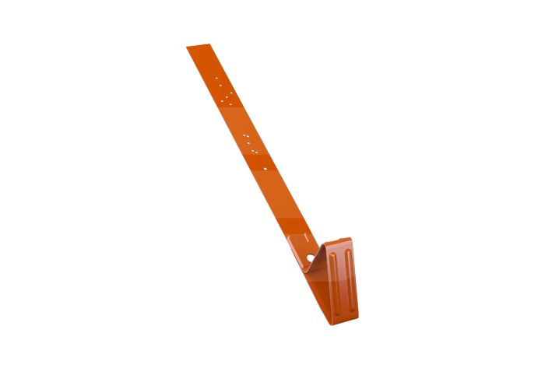
OPRITOR TIP U – flat roofing (acoperis plan)

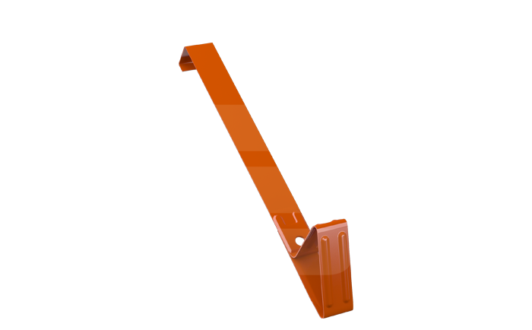
OPRITOR TIP B – tigla ceramica tip:
BRAAS, NELSKAMP, CREATON VIVA, KORAMIC, IBF, EURONIT, JOPEK – beaver tail, RUPP Topas.

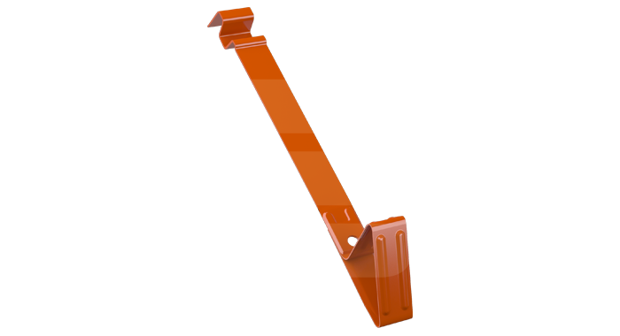
OPRITOR TIP C1 – tigla ceramica tip:
TONDACH Hranice 11, CREATON MZ23, KORAMIC 32, ROBEN Monza Plus, RUUP Tarmaute.

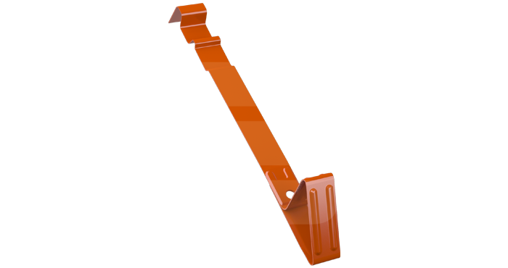
OPRITOR TIP C2 – tigla ceramica tip:
TONDACH Roman 12, CREATON Harmonia Neu, BRAAS /RUUP Sirius 13, KORAMIC E80, JACOBI D10, ROBEN Fleming, ROBEN Bornholm.
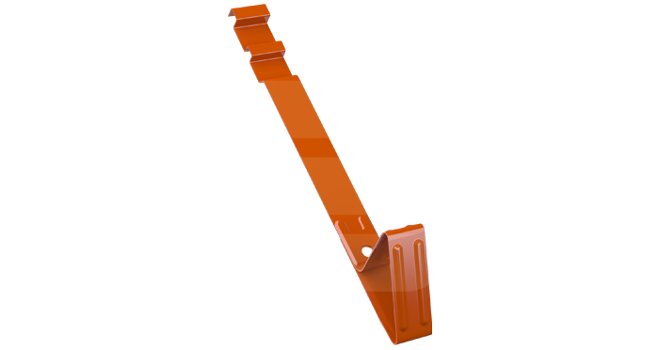
OPRITOR TIP C3 – tigla ceramica tip:
TONDACH French 12/Falcovka/Marseille 12, RUPP Rubin,
CREATON Domino/Ratio Neu/Piatta, BRAAS Amber 12V,
KORAMIC Alegra 89, BOGEN Innovo 12.
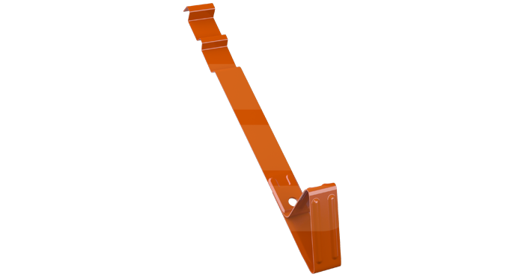
OPRITOR TIP C4 – tigla ceramica tip:
TONDACH French 14 / Marseille 14.

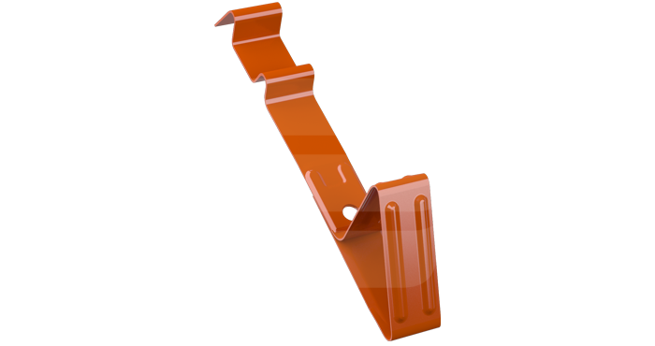
OPRITOR TIP C5 – tigla ceramica tip:
CREATON Balance / Futura / Premion / Harmonica,
TONDACH Roman L15.

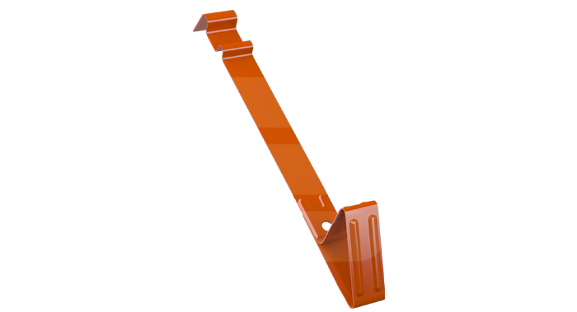
OPRITOR TIP C6 – tigla ceramica tip:
TONDACH Stodo, JIRCANKA.

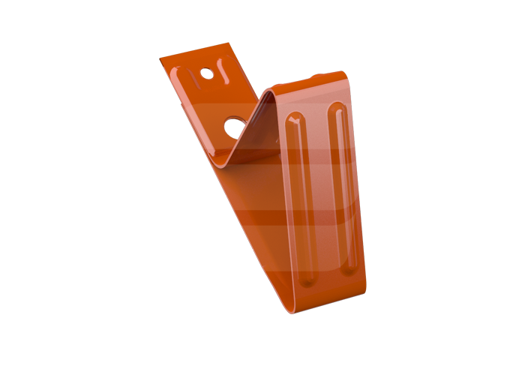
OPRITOR METAL – metal roof covering (acoperis metalic).

